

**AMERICAN INTERNATIONAL**



**UNIVERSITY**



**-**



**BANGLADESH**



408/1



,



Kuratoli

,



Khilkhet,



Dhaka



1229



,



Bangladesh



Assignment Title: **Testing web tech project using Selenium driver**

Assignment: Mid Assignment Date of Submission: 08-09-2024

Course Title: SOFTWARE QUALITY AND TESTING

Course Code: CSC4271 Section: A

Semester: Summer,2023-2024 Course Teacher: ABHIJIT BHOWMIK

**Declaration and Statement of Authorship:**

1. I/we hold a copy of this Assignment/Case-Study, which can be produced if the original is lost/damaged.
2. This Assignment/Case-Study is my/our original work and no part of it has been copied from any other student’s work or from any other source except where due acknowledgement is made.
3. No part of this Assignment/Case-Study has been written for me/us by any other person except where such collaboration has been authorized by the concerned teacher and is clearly acknowledged in the assignment.
4. I/we have not previously submitted or currently submitting this work for any other course/unit.
5. This work may be reproduced, communicated, compared and archived for the purpose of detecting plagiarism.
6. I/we give permission for a copy of my/our marked work to be retained by the Faculty for review and comparison, including review by external examiners.
7. I/we understand that Plagiarism is the presentation of the work, idea or creation of another person as though it is your own. It is a formofcheatingandisaveryseriousacademicoffencethatmayleadtoexpulsionfromtheUniversity. Plagiarized material can be drawn from, and presented in, written, graphic and visual form, including electronic data, and oral presentations. Plagiarism occurs when the origin of them arterial used is not appropriately cited.
8. I/we also understand that enabling plagiarism is the act of assisting or allowing another person to plagiarize or to copy my/our work.

*\* Student(s) must complete all details except the faculty use part.*

** Please submit all assignments to your course teacher or the office of the concerned teacher.

Group Name/No.:

|  |  |  |  |  |
| --- | --- | --- | --- | --- |
| **No Name** | | **ID** | **Program** | **Permit no.** |
| 1 | MST. MEFTAUL JANNAT | 21-45675-3 | BSc CSE |  |
| 2 | MD. ATIK ULLAH KHAN | 21-45677-3 | BSc CSE |  |
| 3 | TAHFIM IBN KHAN | 21-45719-3 | BSc CSE |  |
| 4 | FATEMA AKTHER | 21-45831-3 | BSc CSE |  |

|  |  |  |
| --- | --- | --- |
| ***Faculty use only*** |  | |
| FACULTYCOMMENTS | **Marks Obtained** |  |
|  |
|  |
|  | **Total Marks** |  |
|  |
|  |

**Java (JDK) Setup:**

1. **Firstly, we will download latest JDK file and add to our computer path for java program.**

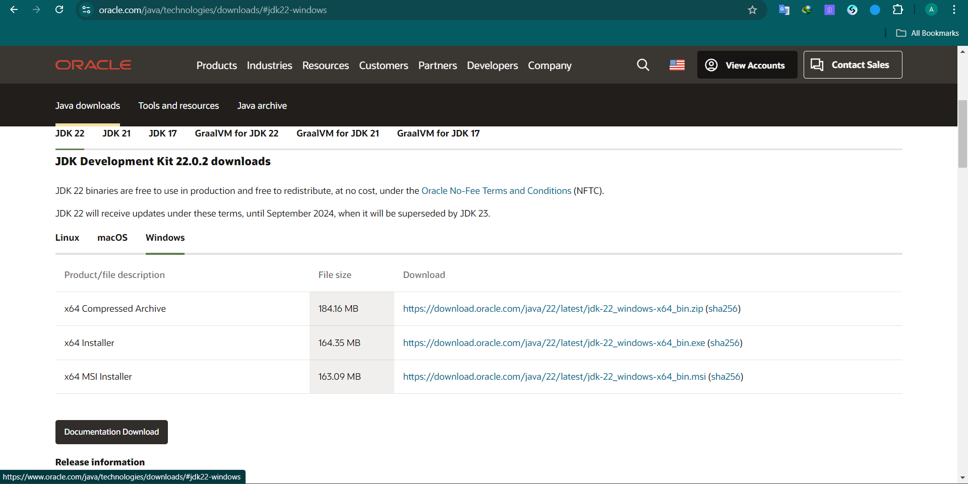

1. **Here, this is the JDK file location**

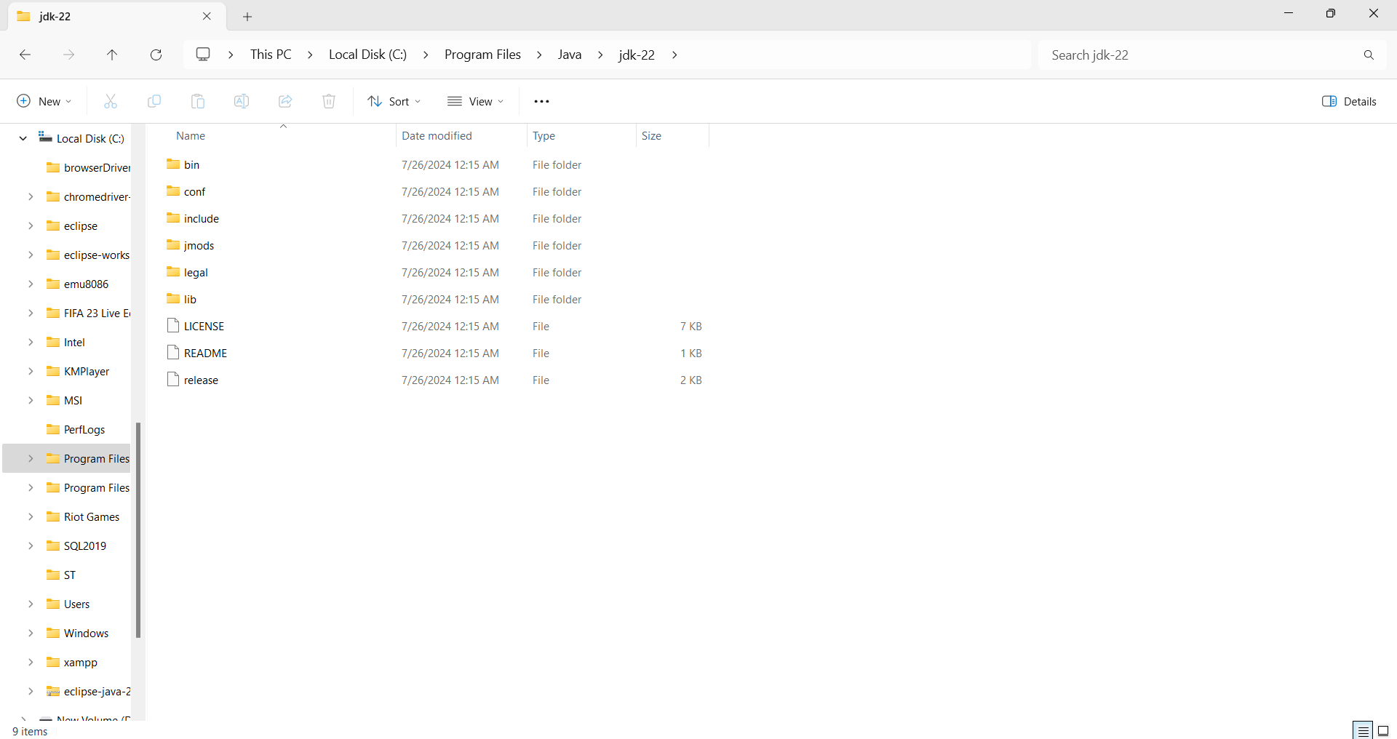

1. **Adding the java path to the computer system properties:**

**This pc > properties > Advance system settings > Advanced > Environment Variables >**

**System variable > Path**

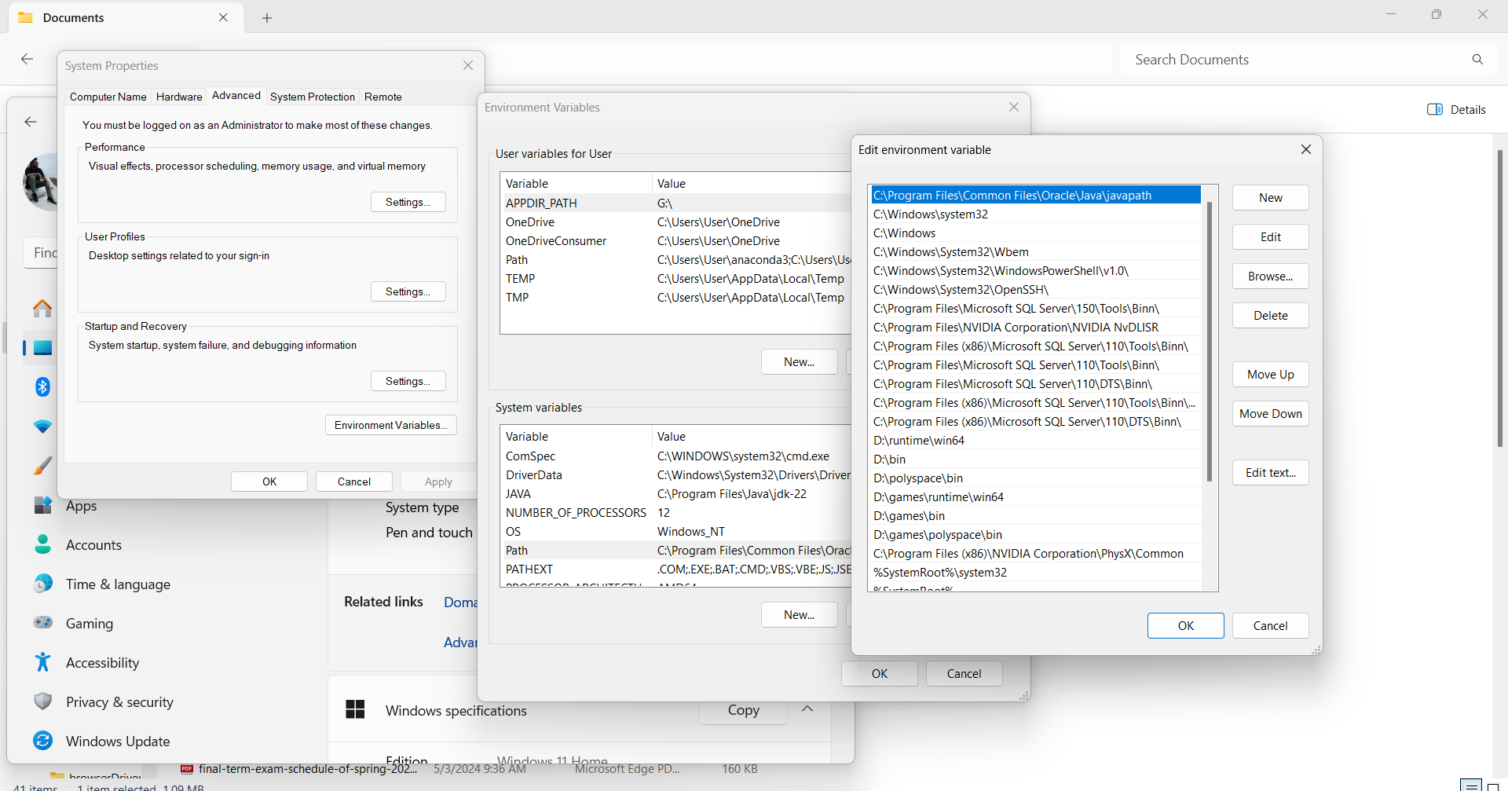

1. **Check the version of JDK and it successfully add to the system**

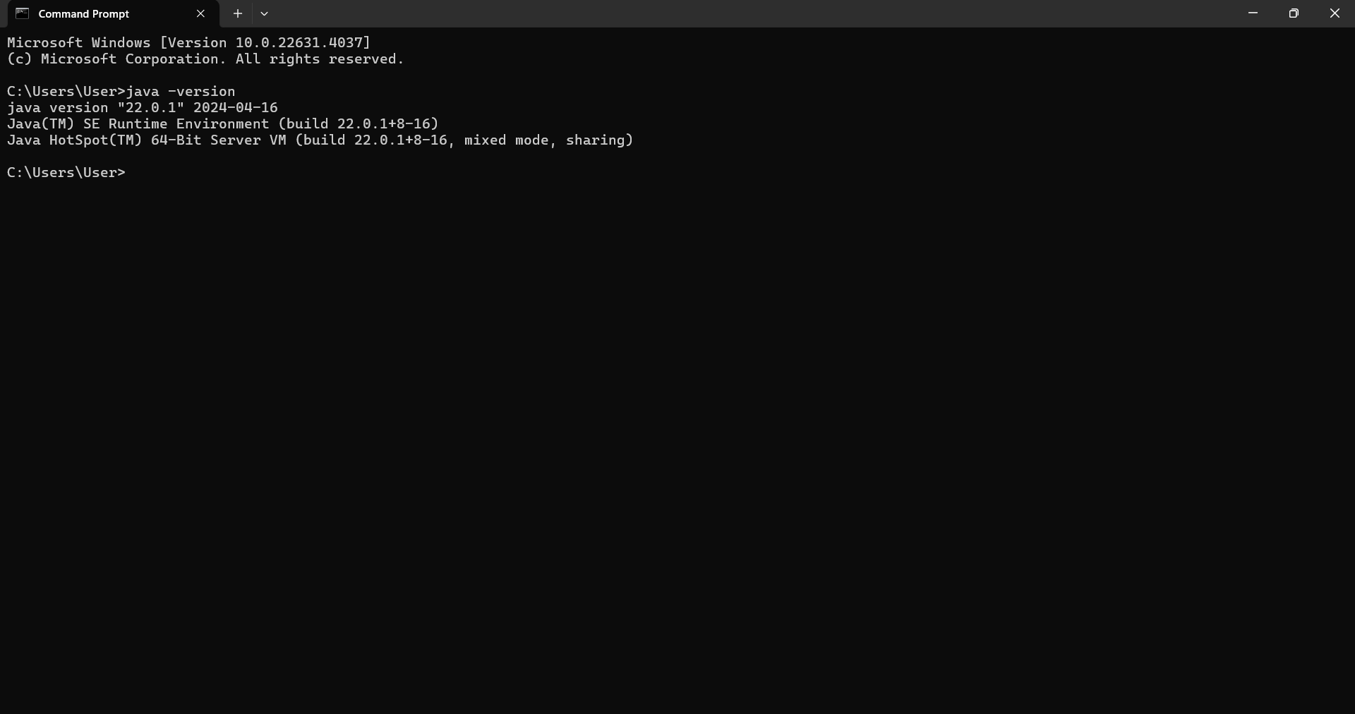

**Eclipse setup:**

1. **We will download Eclipse IDE for Java Developers from https://www.eclipse.org/downloads/packages/**

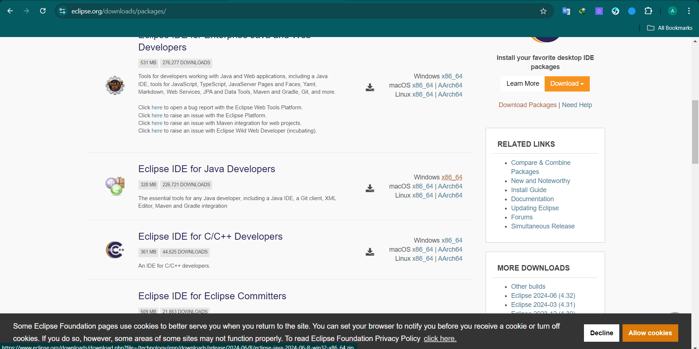

1. **After successfully download eclipse file, we move the file in C drive**

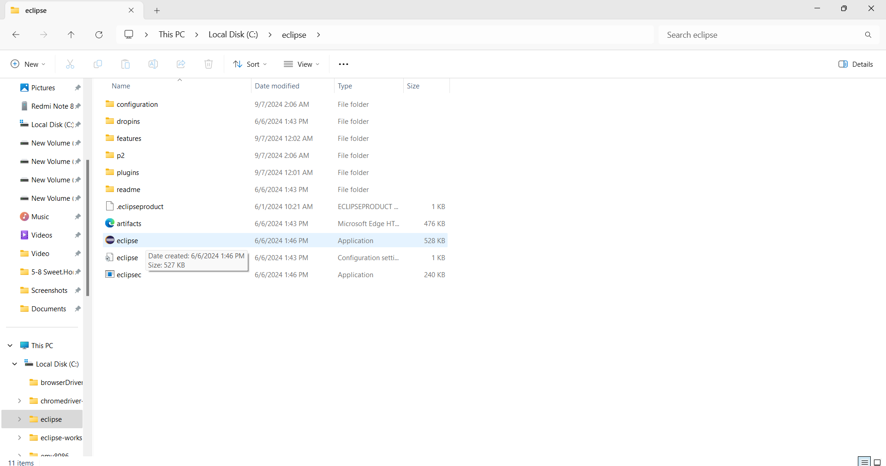

1. **Now we will launch the software**

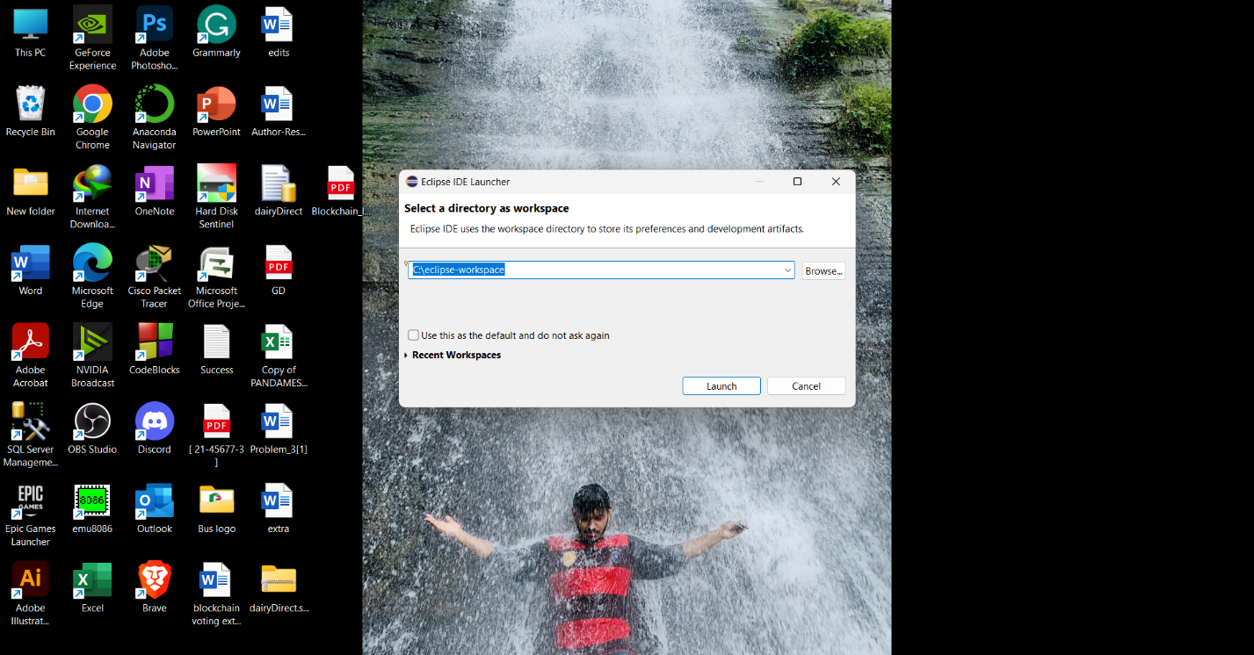

**Selenium Download:**

**Download the latest version of Selenium server from https://www.selenium.dev/downloads/**

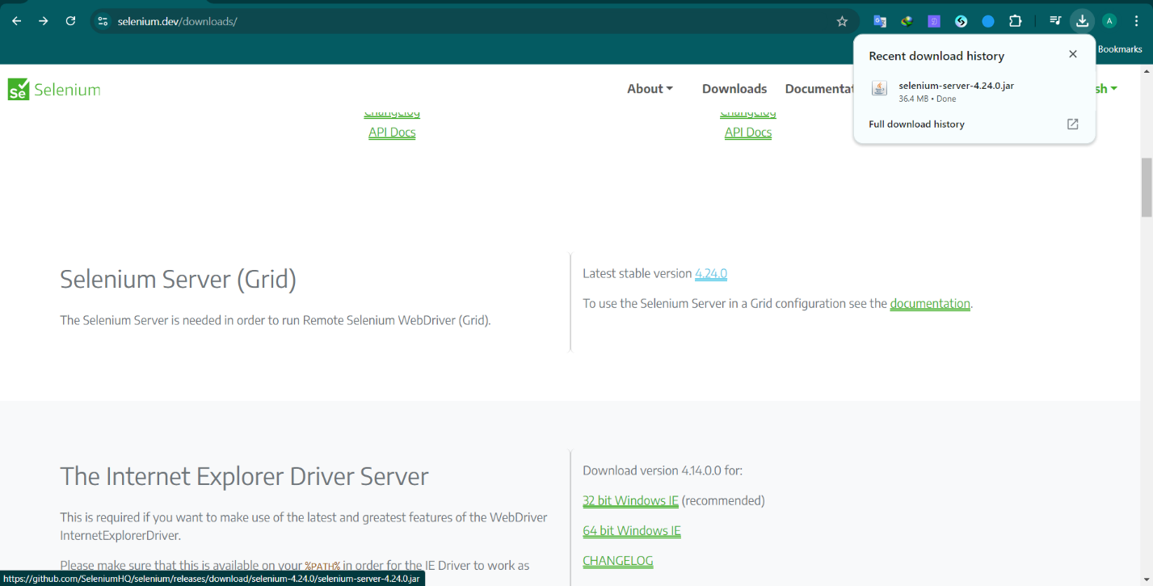

**Chorme Driver Download:**

1. **First, we should check our chrome browser version**

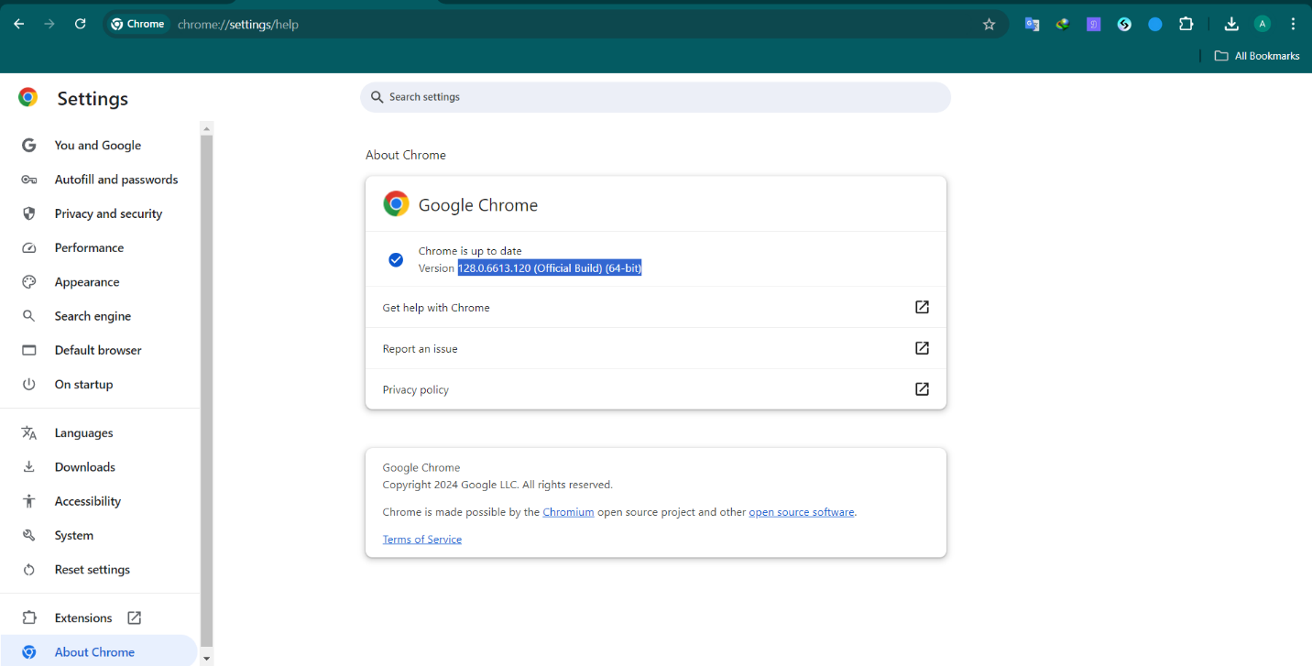

1. **After that we will download chrome driver from** [**https://googlechromelabs.github.io/chrome-for-testing/**](https://googlechromelabs.github.io/chrome-for-testing/)

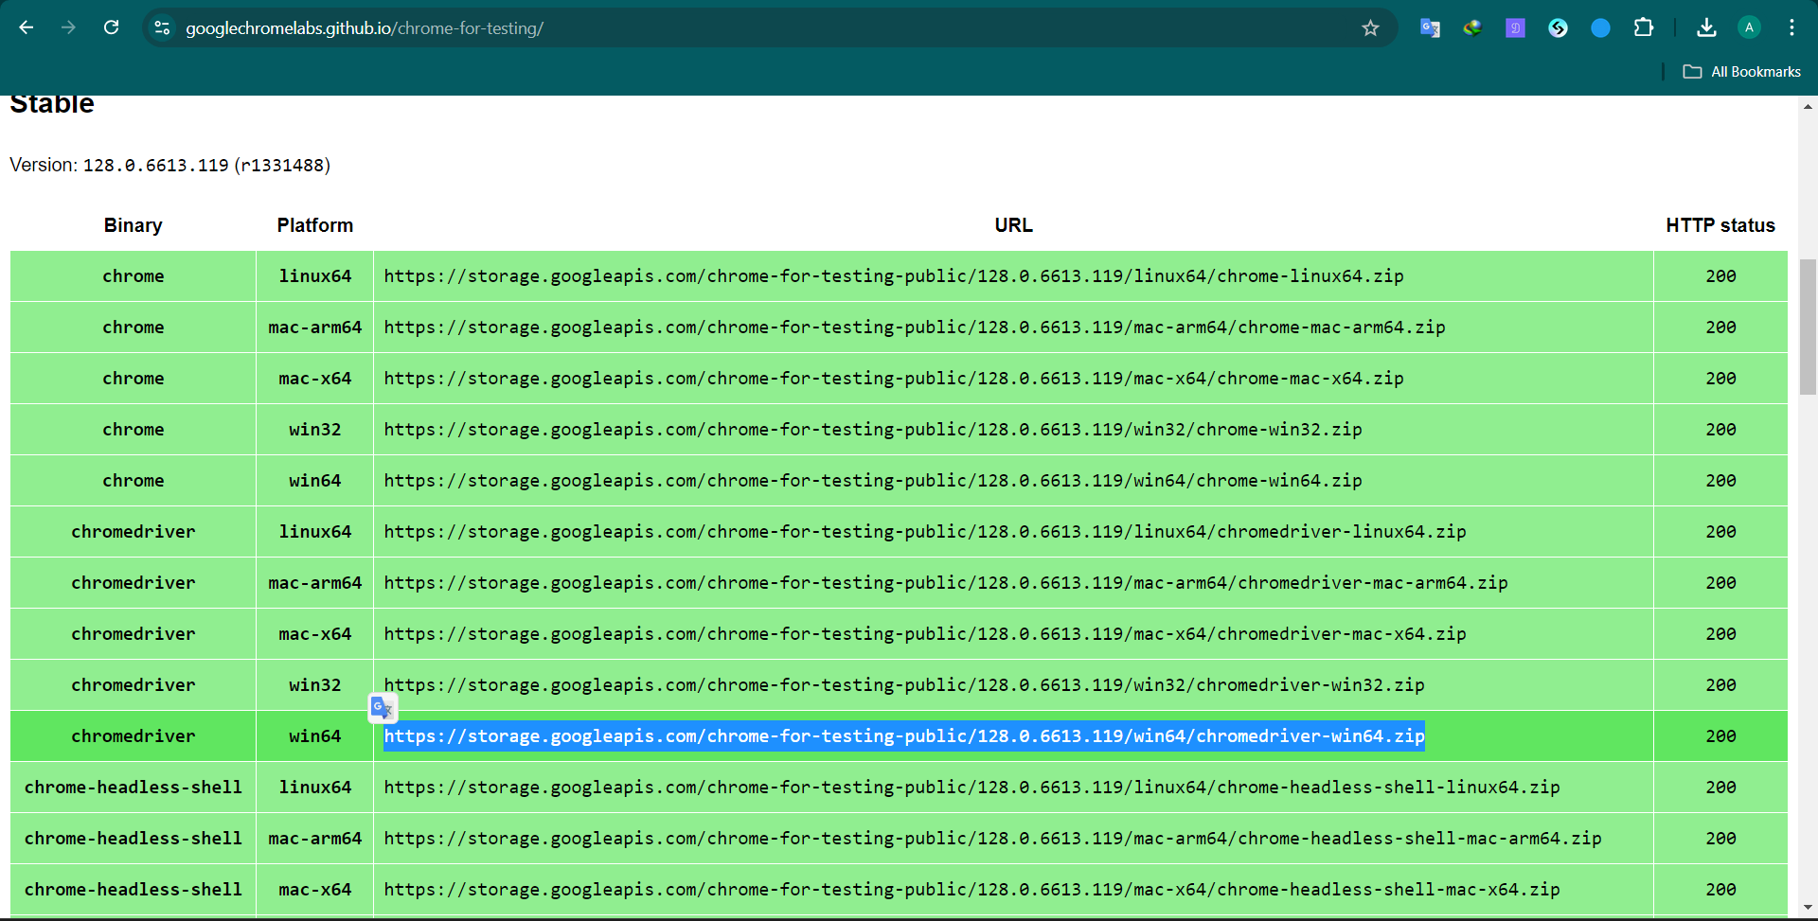

**JAVA project Create:**

1. **Create a java project.**

**File > New > Java Project**

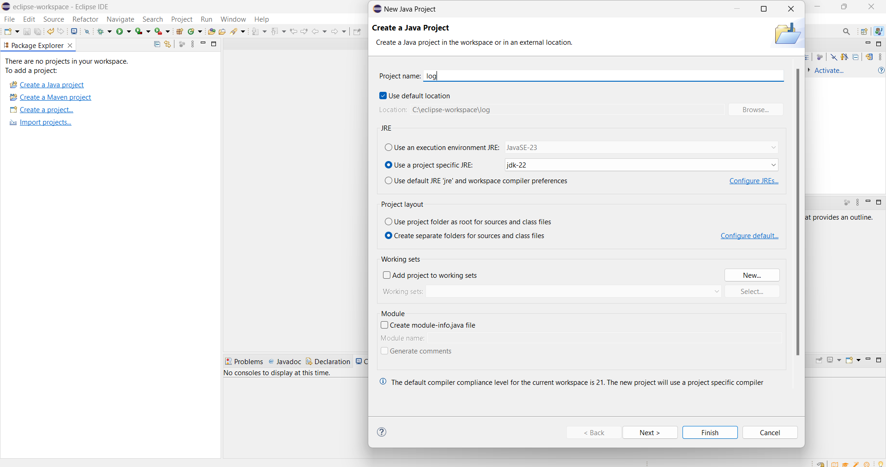

1. **After project create, create a new class.**

**src > New > Class**

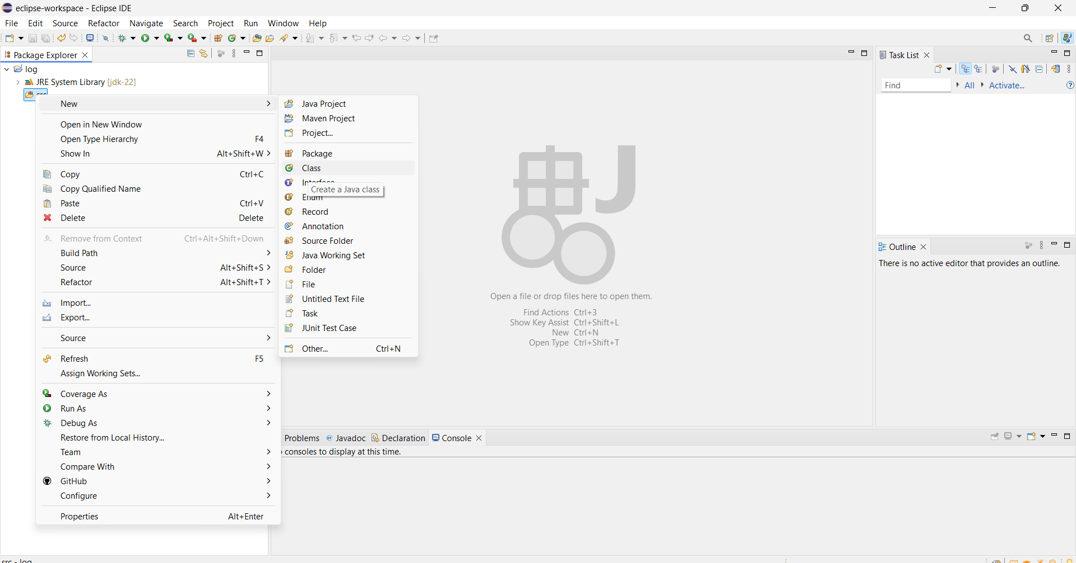

1. **Name the class file and click on (public static void main)**

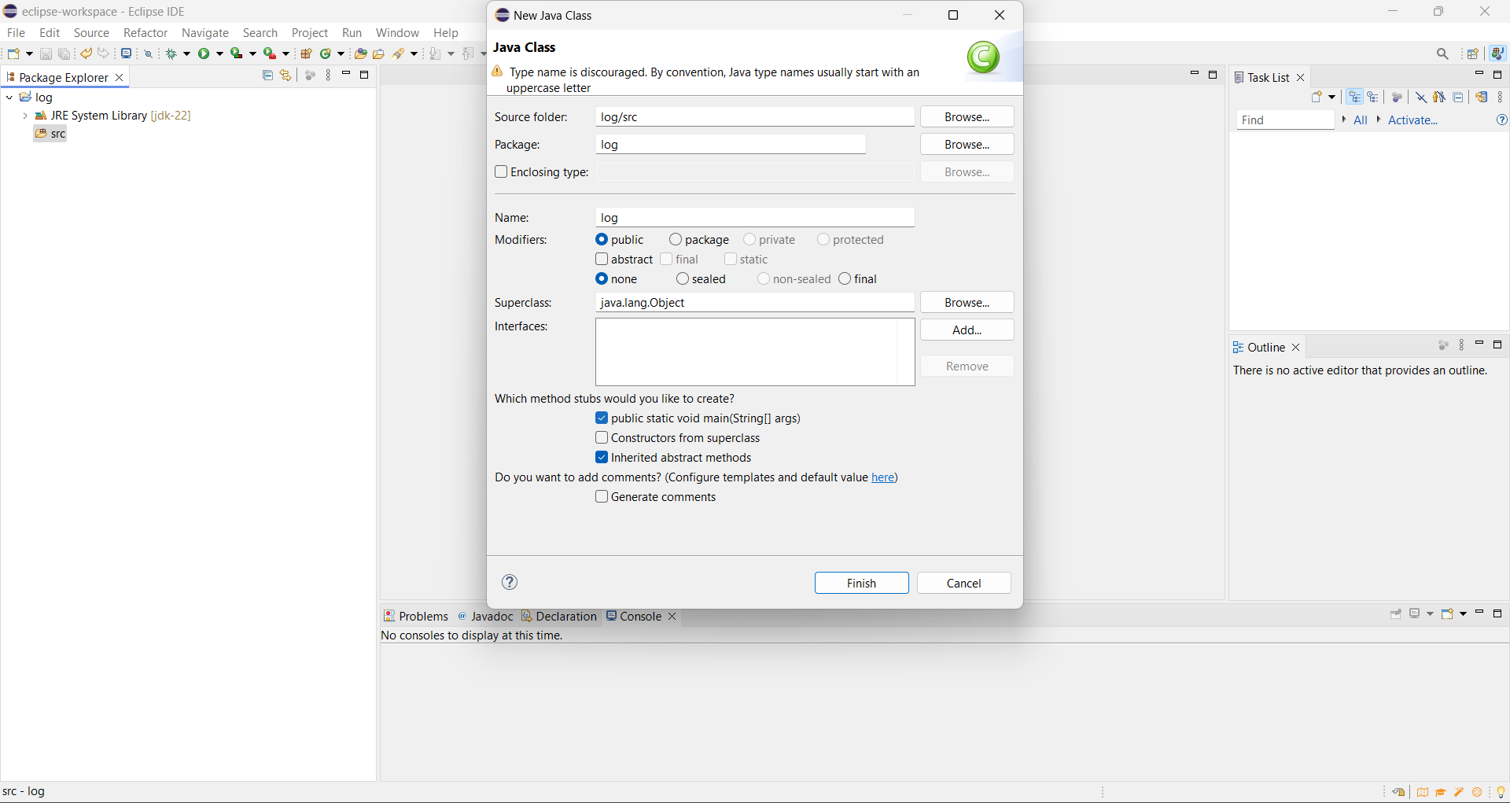

1. **Selenium driver path adding.**

**Java project > Build Path > Configure Build path**

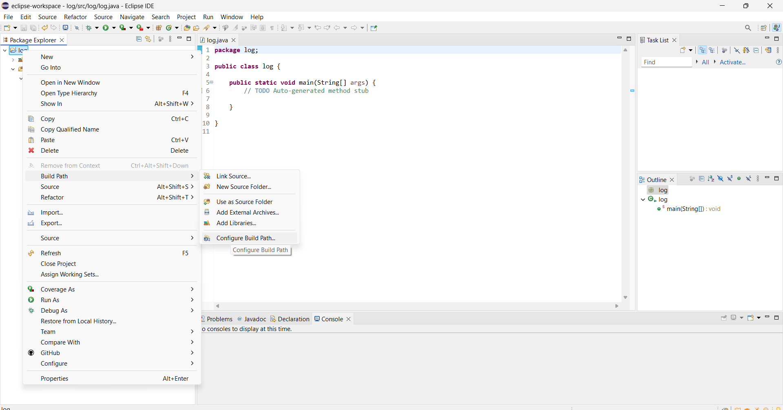

1. **Add Selenium driver in Class path.**

**Libraries > Classpath > Add External JARs**

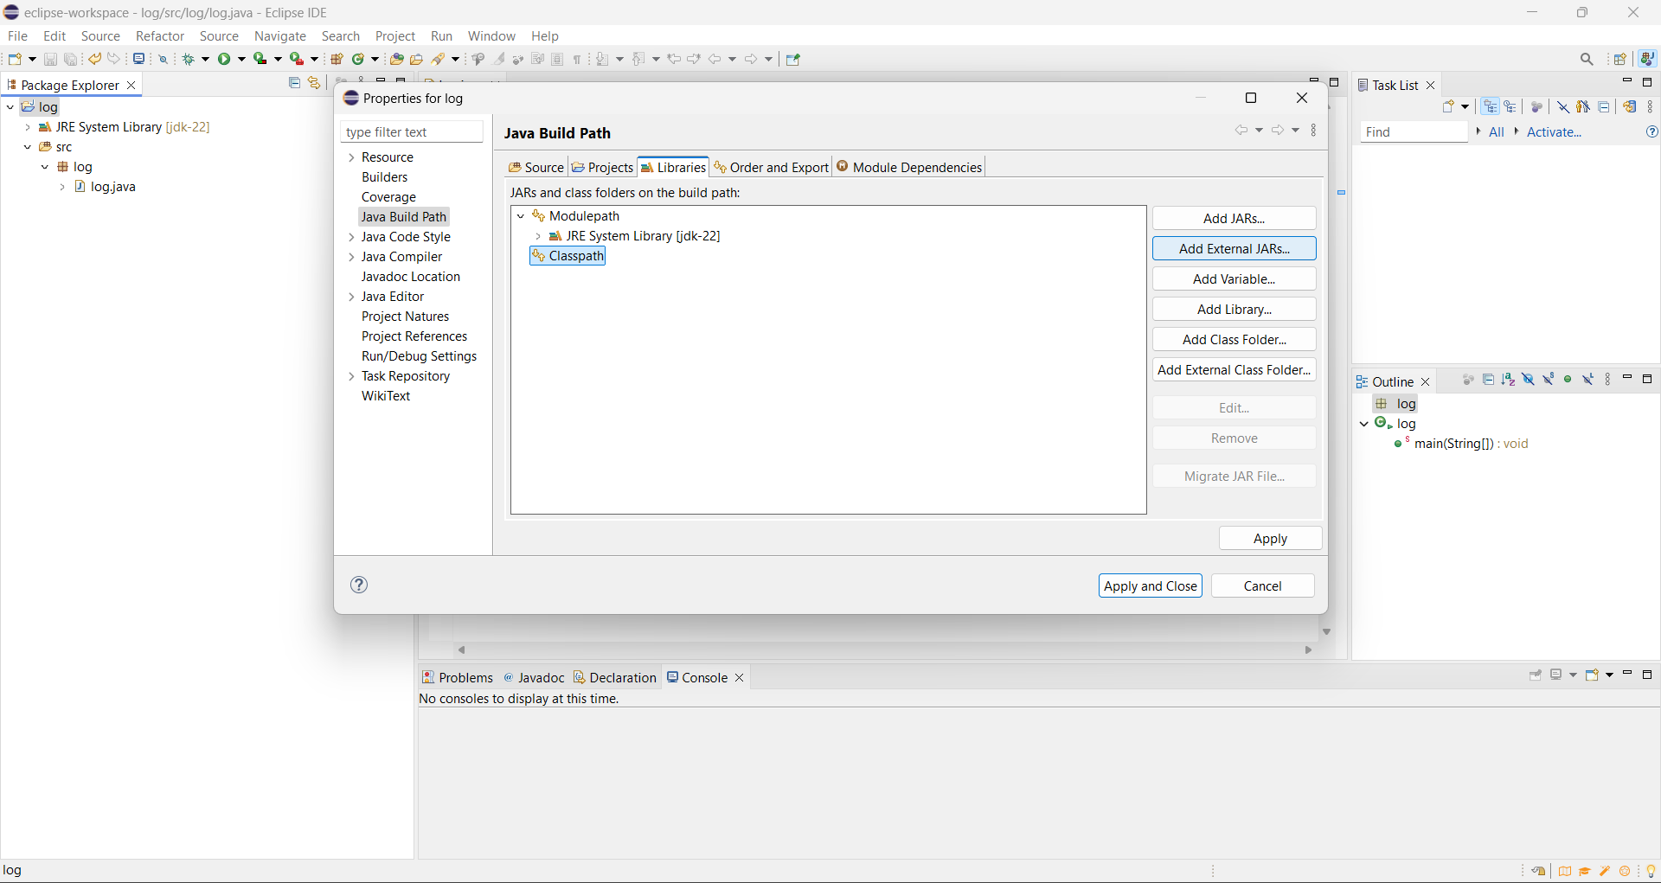

1. **Selenium Driver > Apply and Close**

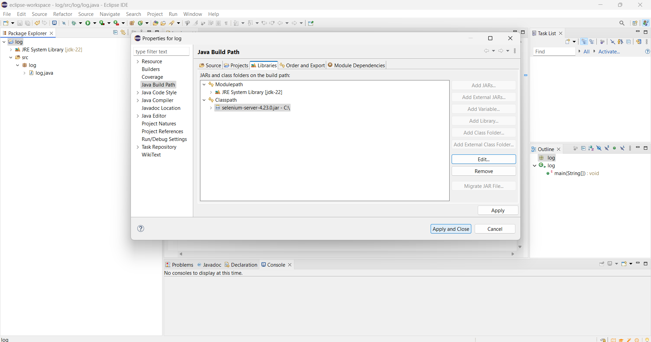

**Testing 1: Homepage**

1. **First Testing code of our web tech project Food. In this code we add chrome driver add our testing browser.**

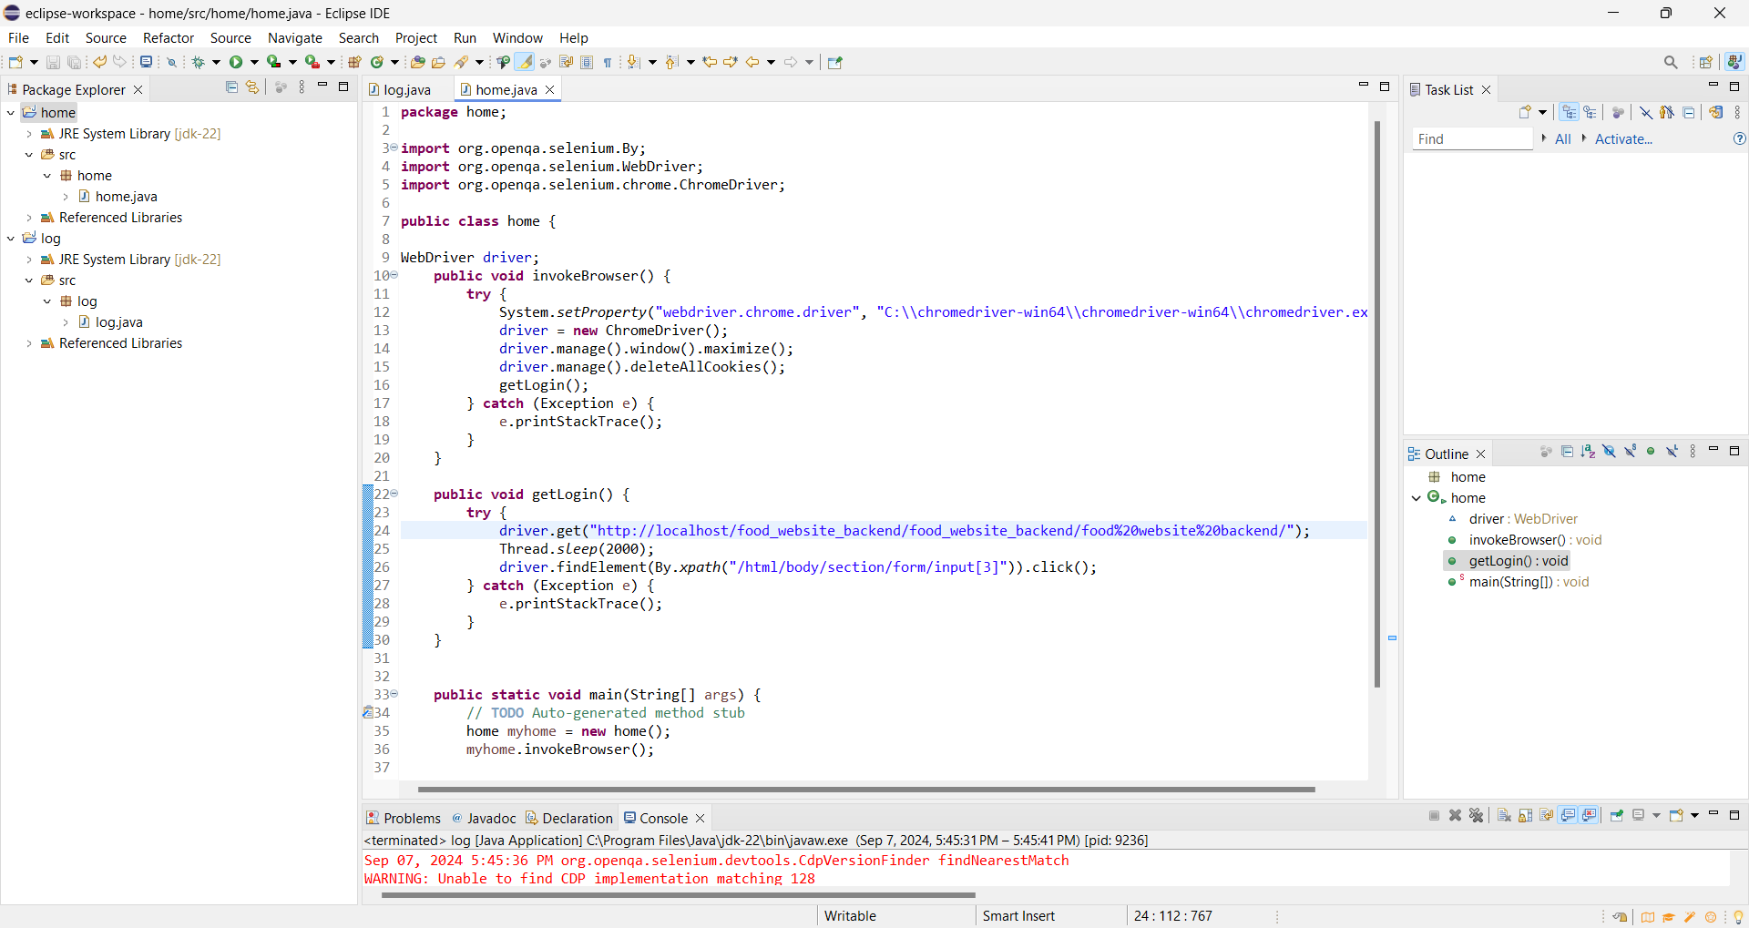

1. **After successfully run the project.**

**Testing 1: log project successfully passes the test and run smoothly. Here we see the homepage of our web project Homepage**

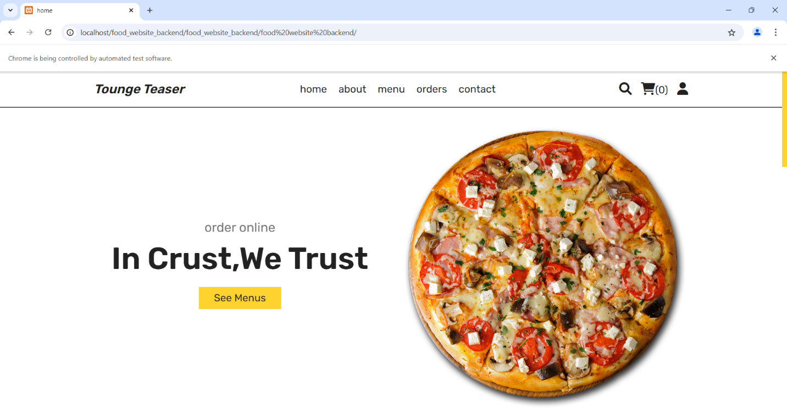

**Testing 2: Login**

1. **Here we use valid email address and pass**

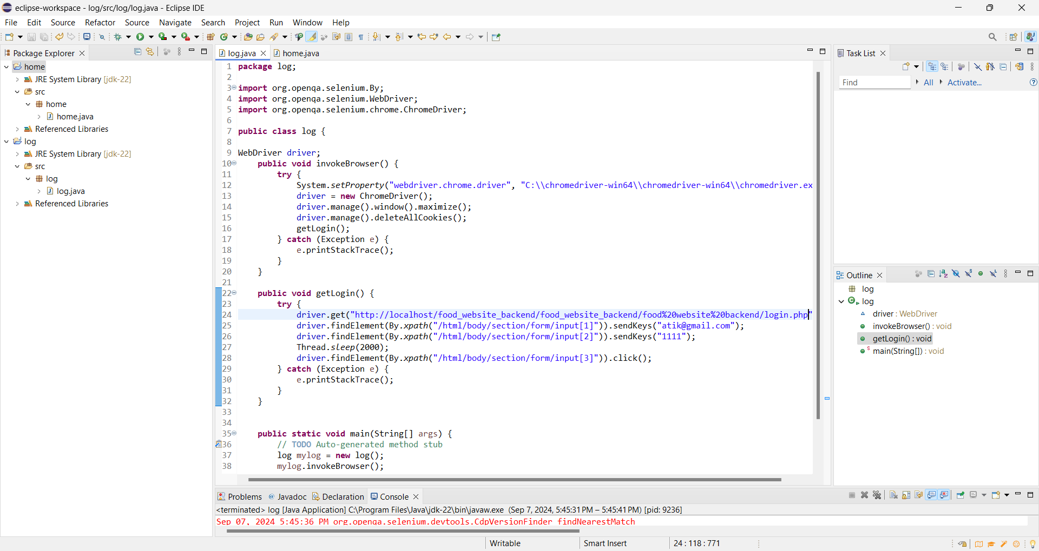

1. **After Successfully run email and password auto fill up**

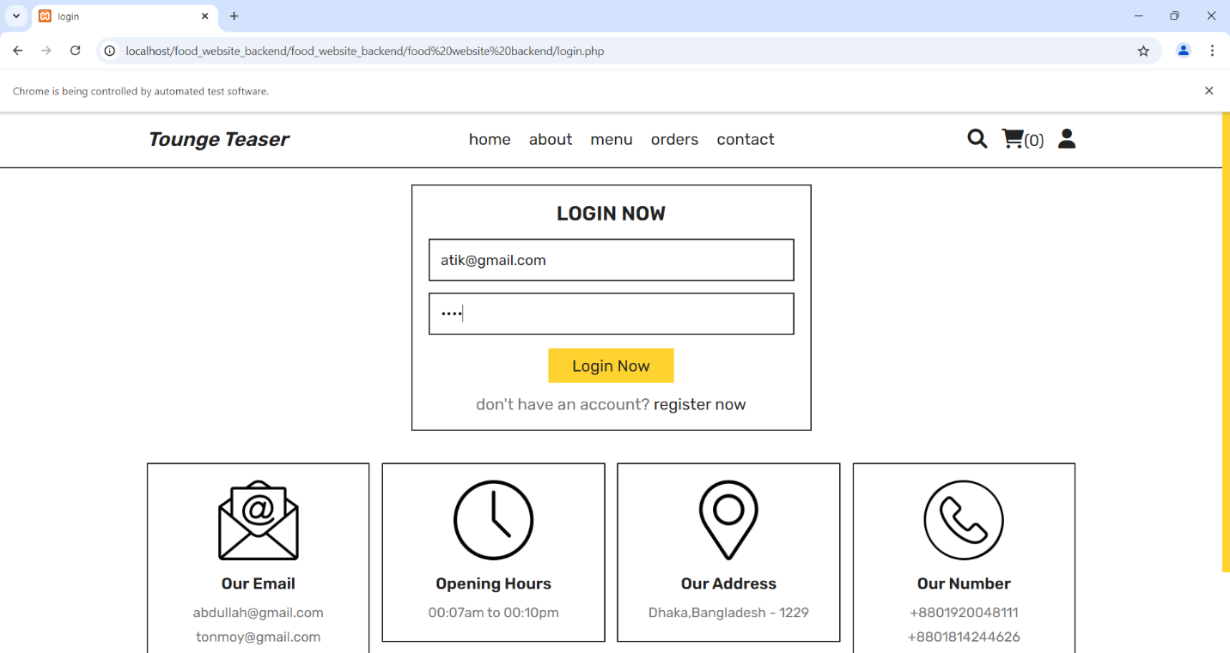

1. **Here after Successful login**

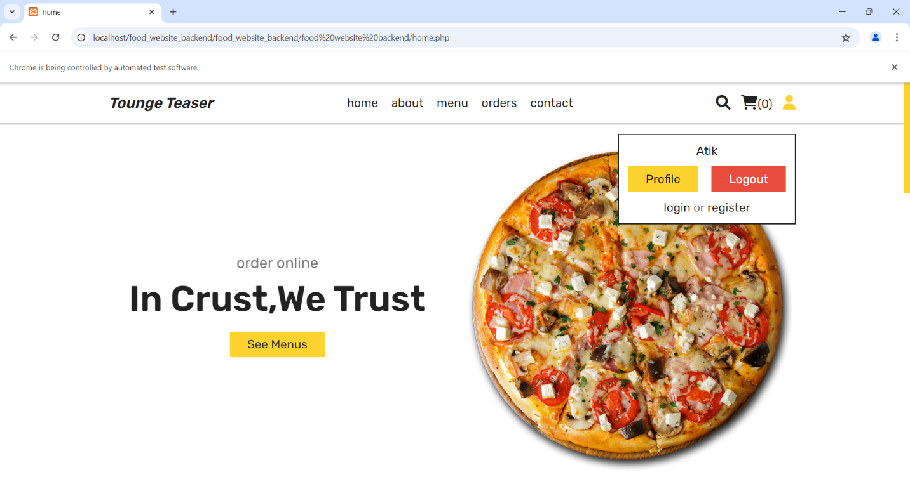

**Testing 3: Register**

1. **We use name, email, number and pass as register information**

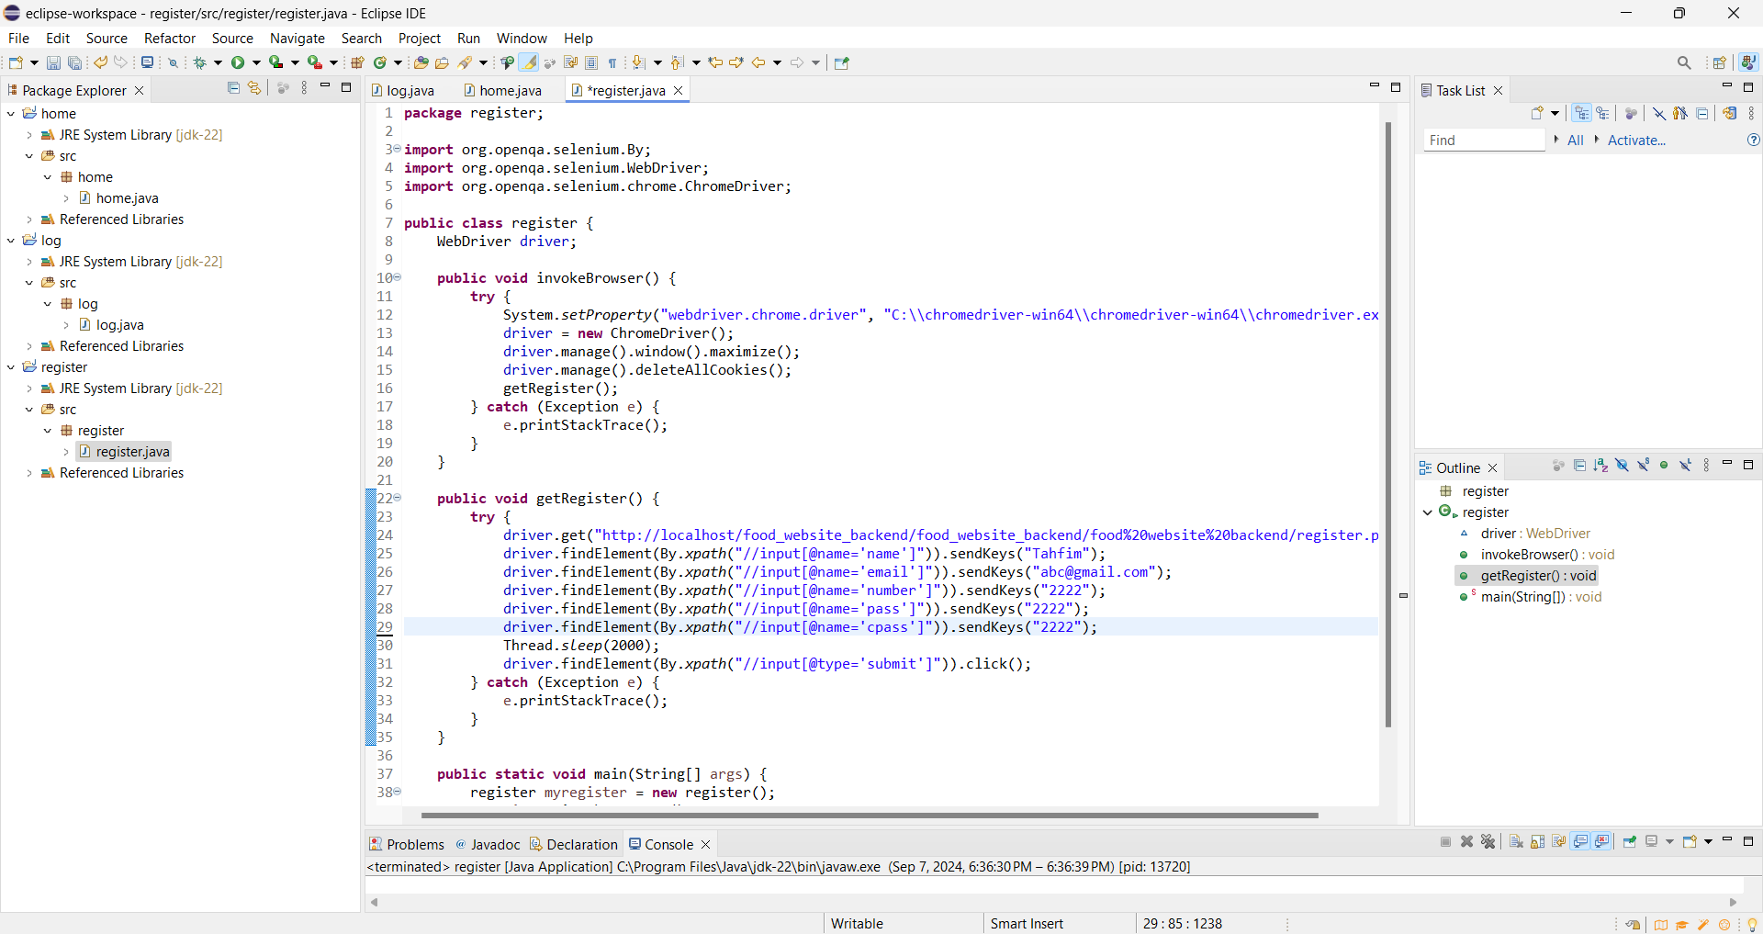

1. **Auto fill up the information**

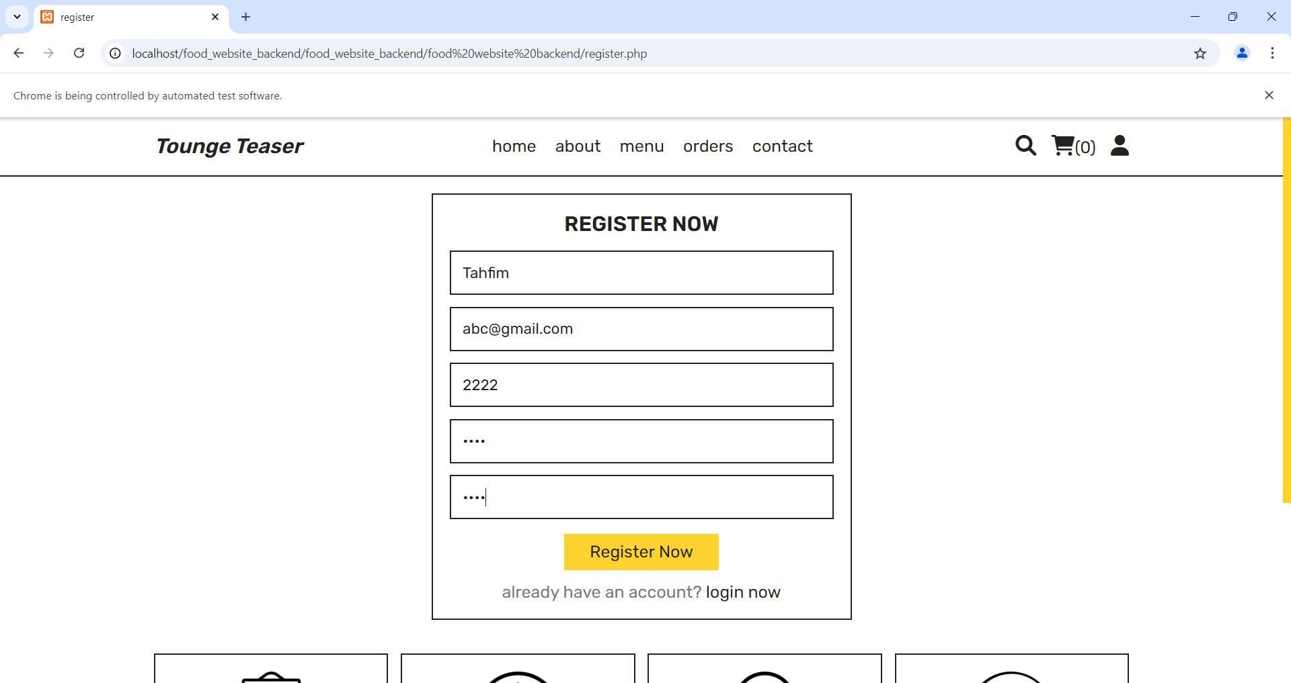

1. **After complete registration, user automatically login**

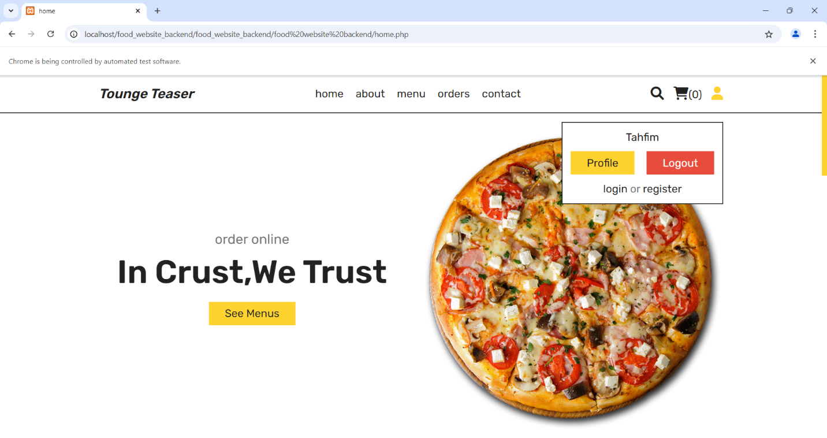

**Testing 4: Cart**

1. **We use valid user email and password to show the cart information.**

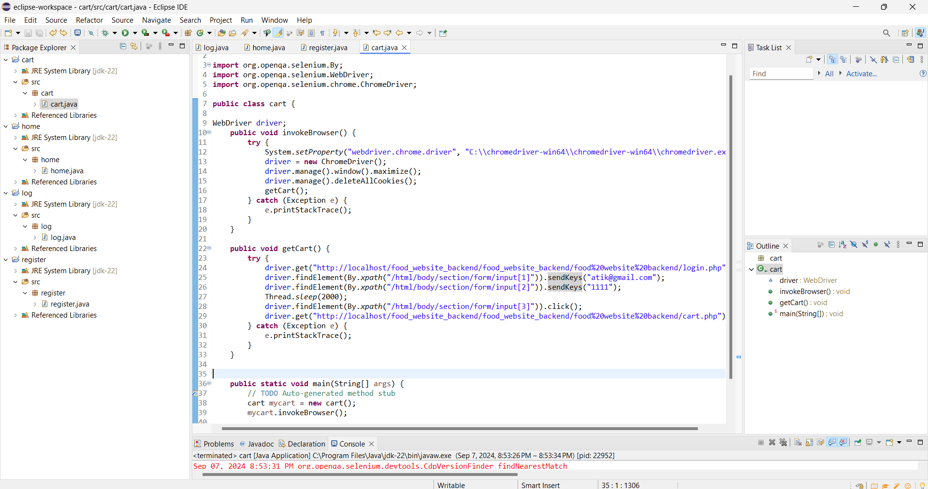

1. **Auto fill up login information**

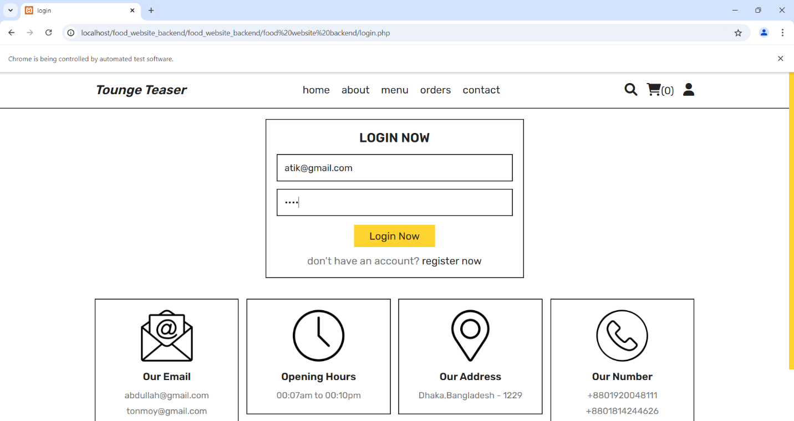

1. **Here is the valid user Cart**

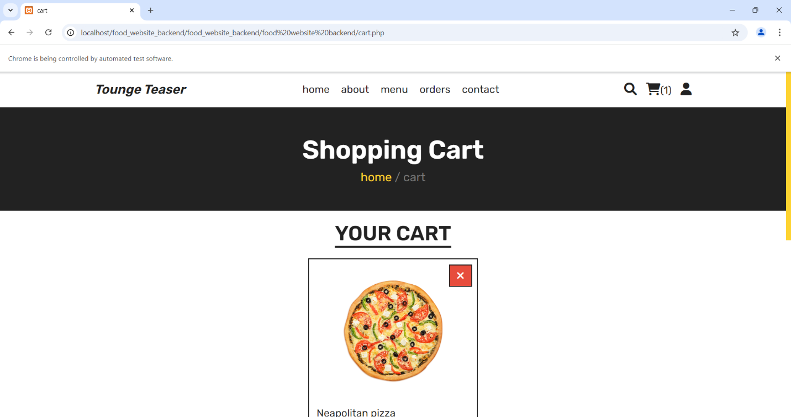

**Testing 5: Menu**

1. **Testing code for menu part**

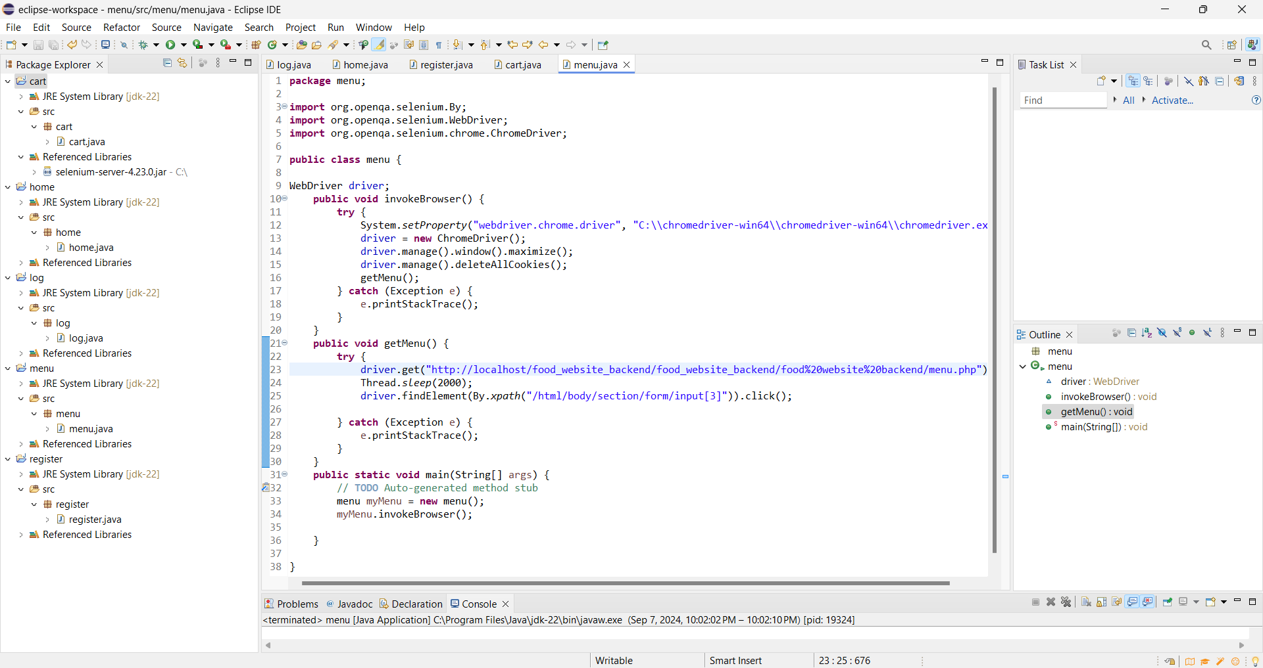

1. **Here is the menu page**

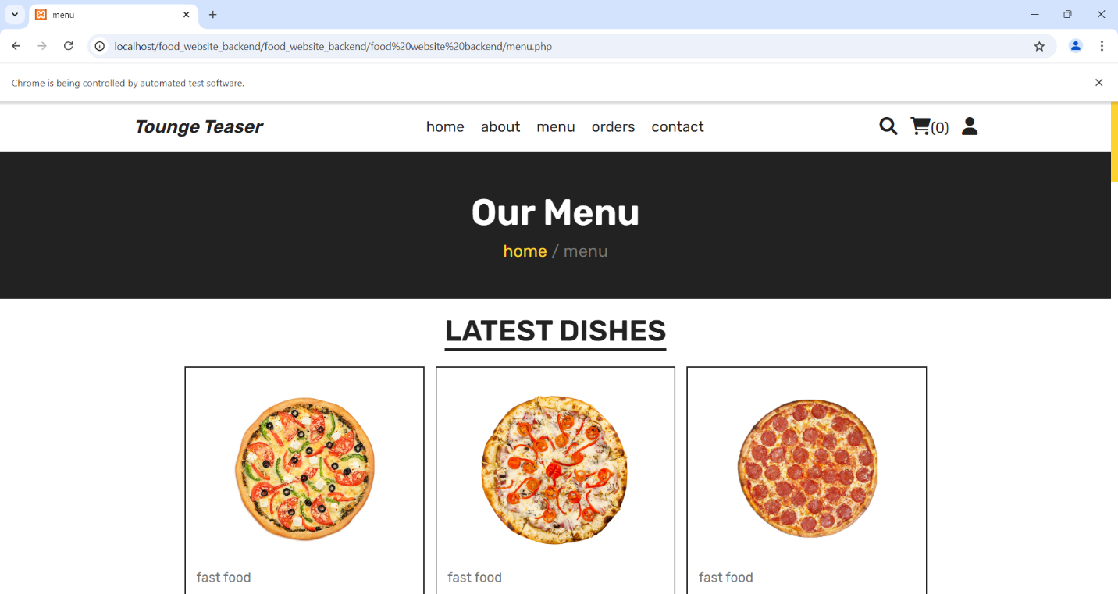

**Testing 6: Contact**

1. **Any user can contact by provide name, number, email, comment**

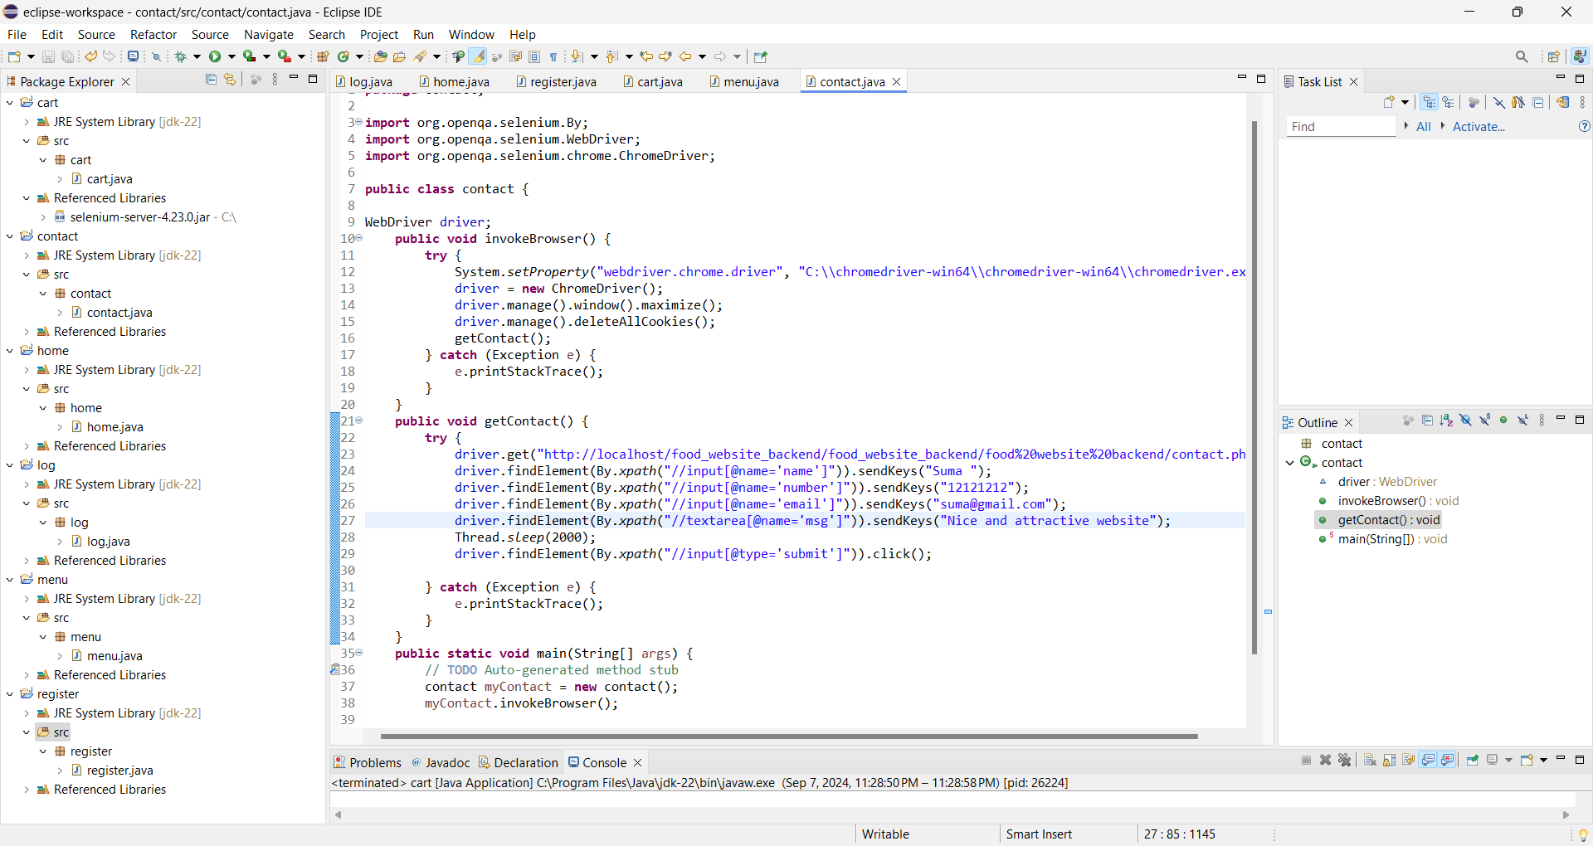

1. **Auto fill up the information**

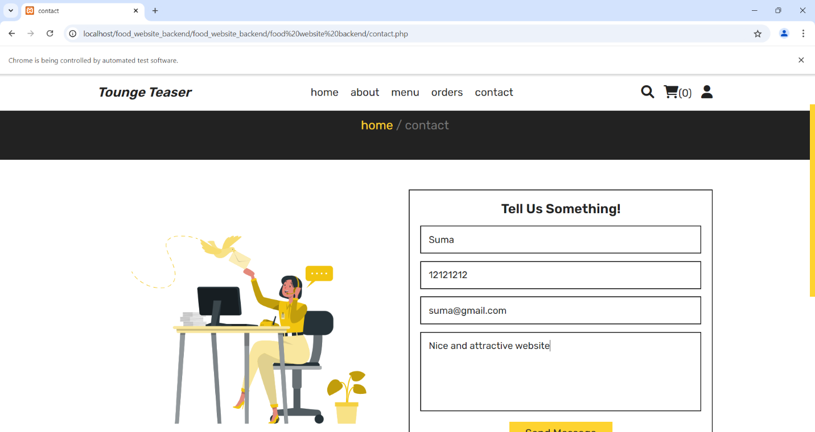

1. **After successful submission, submission message pop-up**

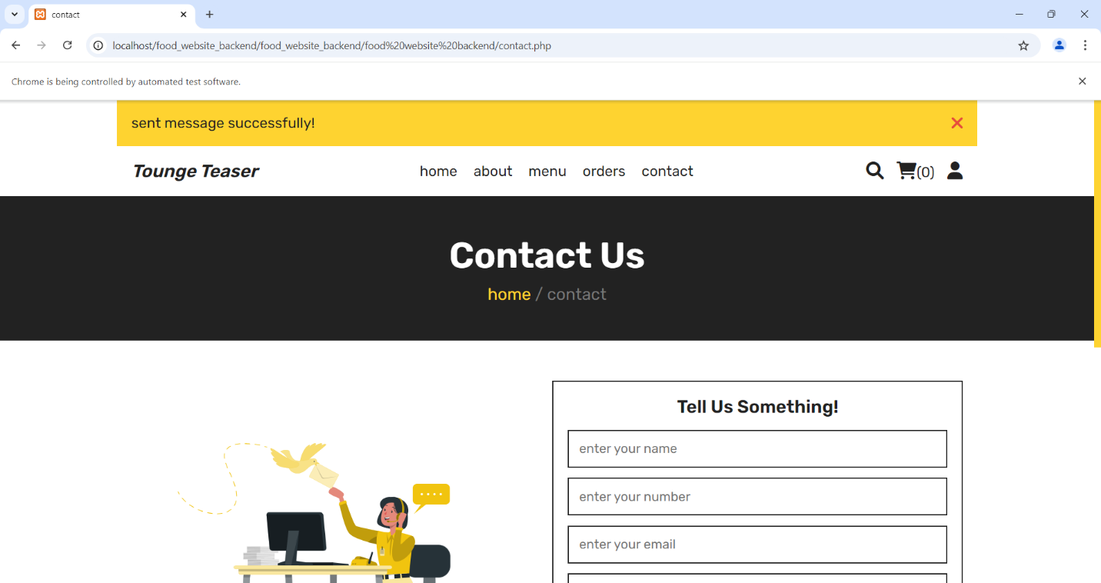

**Testing 7: Checkout**

1. **We use valid user email and password to show the cart information.**

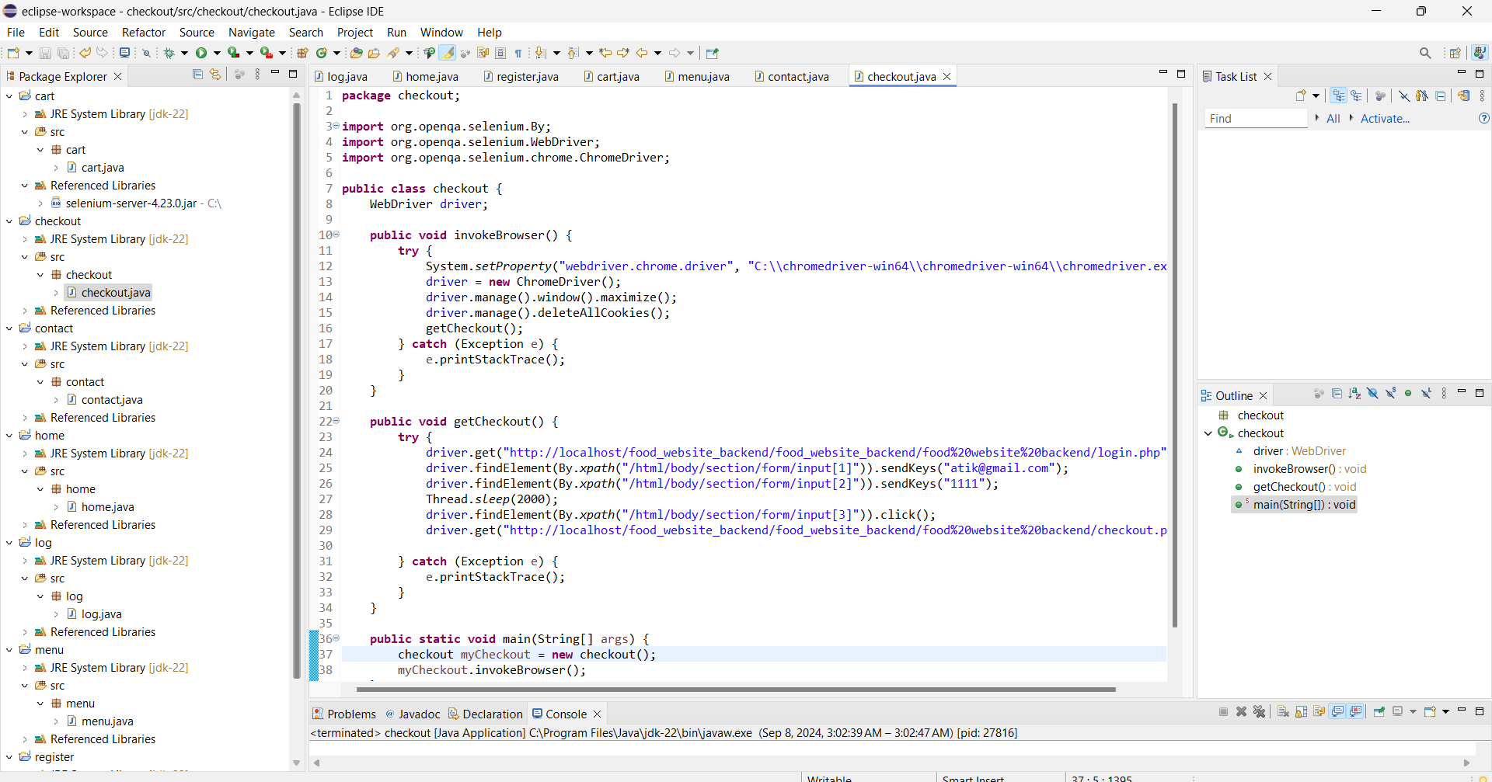

1. **Auto fill up login information**



1. **Here is the valid user Checkout**

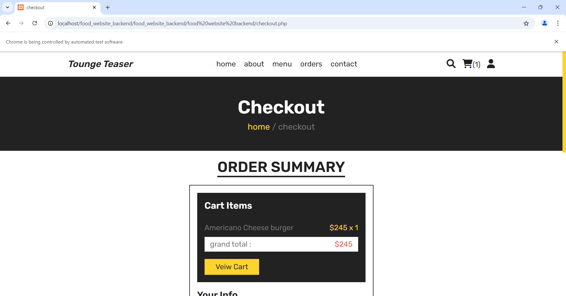

**Testing 8: Search**

1. **For search item, we use Burger as product name.**

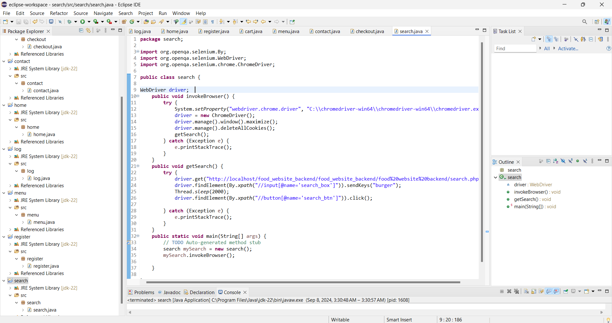

1. **Auto fill up search box and click search button.**

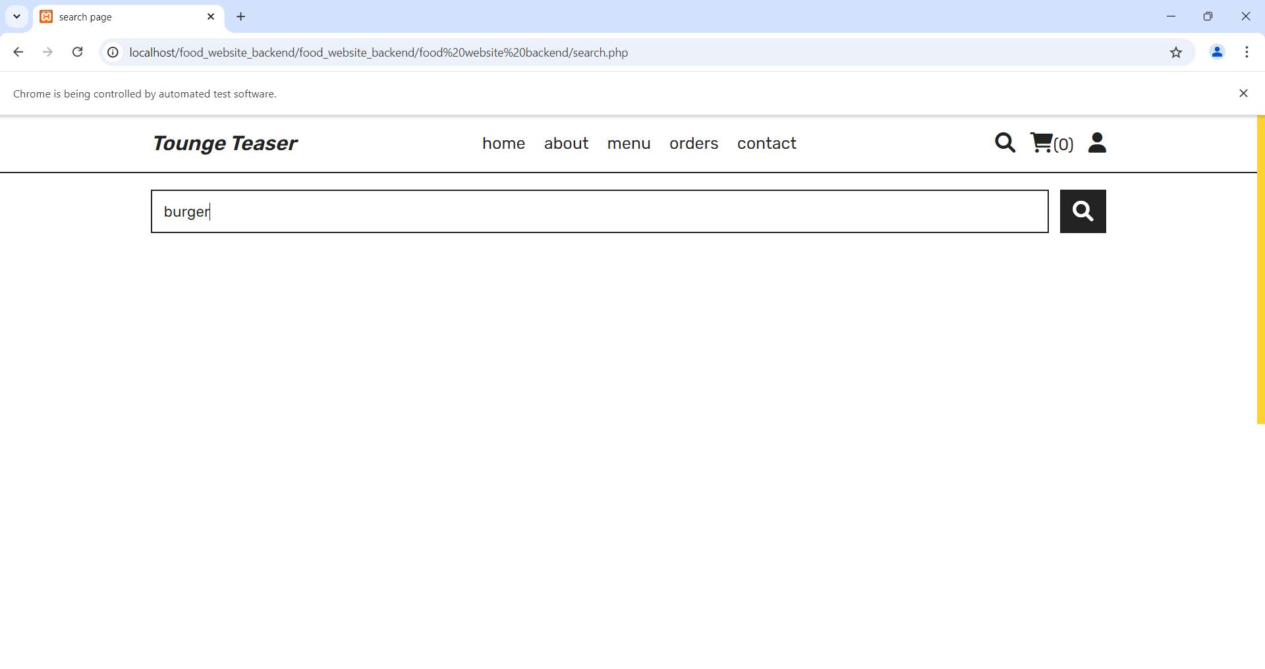

1. **Searching result show**

